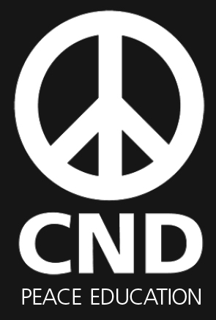
CND Peace Education: School Speaker volunteer role description

The Peace Education programme of the Campaign for Nuclear Disarmament (CND) is looking for School Speaker volunteers to deliver assembly talks and facilitate classroom workshops on peace and nuclear weapons issues.

These positions would suit people with an interest or background in education, working with children and young people, peace and conflict issues, nuclear issues, training and public speaking.

Key details:

Location: We are looking for School Speakers based in London, the South East, North West and the North East
Length of volunteering period: Ongoing
Hours: As a volunteer you will not be required to volunteer set hours. However, we would ideally like you to commit to 1-2 school sessions a month, depending on demand from schools in your area. Sessions take place Monday - Friday during school hours. Our talks and workshops usually last for 1 hour, although a school may wish to have more than one session in a day.
Remuneration: Travel and reasonable refreshment expenses will be reimbursed.

About the Peace Education Programme
The CND Peace Education programme is charitably funded by the Nuclear Education Trust and aims to empower young people with knowledge on peace and nuclear weapons issues. We do not campaign in schools: rather, we support independent thinking and encourage debate, enabling young people to form their own opinions.

Our free, cross-curricular workshops and talks engage thousands of 7-18 year-old school students across England each year. Many of these sessions are facilitated/delivered by School Speakers.

In addition, thousands of our free, award-winning teaching packs are downloaded or distributed as hard copies annually. Our sessions and teaching resources support critical thinking through creative and collaborative active-learning, from role-play and group presentations to debates and origami.

We also offer free training for teachers on how to teach controversial issues; School Speakers can also facilitate some of these sessions, on completion of further training. There are also opportunities to help promote CND Peace Education’s work via stalls at teacher conferences. For more information on our work, please visit https://cnduk.org/education

What we can offer you
- A free half-day of initial training to familiarise you with what we do, and to try out some of our education activities
- Opportunities to shadow an experienced School Speaker before you facilitate/deliver
- A great role where you can develop your existing skills and gain new ones, as part of a friendly team that has a big real-world impact each year
- Reimbursement of reasonable travel and refreshment expenses

Main aspects of the role
- Delivering or co-delivering assembly talks to primary and secondary school students
- Facilitating or co-facilitating workshops for primary and secondary school students
- Promoting the School Speaker sessions to your local schools
- Liaising with teachers ahead of sessions, and preparing the resources you need (with support from the Peace Education Officer)

Person specification
  - Commitment to the aims and objectives of CND and its education programme (see https://cnduk.org)
  - Interest/degree in Education/Peace Studies/Politics or similar
  - Confident working with children and teenagers
  - Ability to communicate enthusiastically and effectively with young people, and teachers
  - Good interpersonal skills
  - Responsible, organised and reliable
  - IT literate, especially: competent working with PowerPoint, YouTube, and email
  - Ability to work independently and as part of a team

DBS checks
It is not necessary to have an Enhanced or Standard Disclosure and Barring Service (DBS) check, as School Speakers do not go into schools often enough for the role to be eligible for checks: the Government definition of ‘regulated activity’ is once a week or more, or four or more times each month. Nor is it necessary to have a basic DBS check, as School Speakers must always be supervised by a teacher from the school. However, it is helpful if you have had a recent DBS check for another role (whether Enhanced, Standard, or Basic).
How to Apply
Please submit by email the following:
- A cover letter outlining:
- How you meet the criteria in the person specification
- Why you would like to be a School Speaker
- Your availability during school hours
- Your CV, including contact details for two referees
- A completed Equal Opportunities form (see the separate attachment)
Please email your application to: peaceeducation@cnduk.org
Please note:. Successful candidates will need to attend a half-day of initial training which can be by Zoom. After completing the initial training, School Speakers shadow the Peace Education Officer (and/or experienced School Speakers) as they deliver sessions in schools, and then either co-deliver or are shadowed delivering solo. Once both parties are happy, the new School Speaker can deliver sessions in schools solo.

