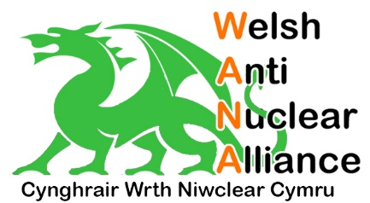
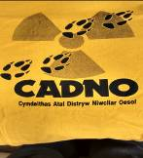
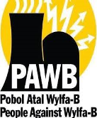

JOINT SEMINAR FOR A GREEN NUCLEAR FREE WALES
“WELSH ENERGY AT A CROSSROADS – CHARTING A SUSTAINABLE, RADIOACTIVE WASTE FREE FUTURE”
Saturday 13th April, Telford Centre, Mona Road, Menai Bridge, Anglesey, LL59 5EA – 10.30am – 1.30pm

10.30am – 11.00am registration

11.00am Local welcome and opening comments
Councillor Steven Churchman, Gwynedd County Councillor
Councillor Ernie Galsworthy, NFLA Welsh Forum Chair

11.10am Moving on from the ‘halting’ of Wylfa B
The ‘Manifesto Mon – Gwynedd’ – developing a renewable energy region in Anglesey and Gwynedd as part of an economic trans-formation of the area - Rob Idris, on behalf of PAWB & CADNO

11.35am Small Modular Nuclear Reactors – are they an energy solution in North Wales?
Overview of a new analysis of SMRs by the Nuclear Consulting Group - Steve Thomas, Professor of Energy Policy, Greenwich University

12.00pm Where should the radioactive waste go?
The NFLA’s view on the current debate about hosting a deep underground radioactive waste repository - Sean Morris, NFLA Secretary

12.25pm Developing local renewable energy networks across Wales
The work of Rural Energy Developments / Datblygiadau Egni Gwledig (DEG) Ltd in supporting community-led action for a low-carbon renewable North Wales - Gareth Harrison, DEG Wales

12.50pm Panel discussion and conclusions
Chaired by Dr Carl Iwan Clowes, PAWB / CADNO

JOINT SEMINAR FOR A GREEN NUCLEAR FREE WALES
“WELSH ENERGY AT A CROSSROADS – CHARTING A SUSTAINABLE, RADIOACTIVE WASTE FREE FUTURE”
Saturday 13th April, Telford Centre, Mona Road, Menai Bridge, Anglesey, LL59 5EA – 10.30am – 1.30pm

This seminar is a public meeting open to all interested in the impact of new nuclear and waste on Wales, and what alternative energy solutions exist.

This meeting has been co-organised by the Nuclear Free Local Authorities Welsh Forum, the Welsh Anti-Nuclear Alliance (WANA), People Against Wylfa B (PAWB), the local Trawsfynydd concerned group CADNO and CND Cymru with support from Friends of the Earth Cymru and Greenpeace Cymru, so that you can hear their views and join with them in the campaign for a green nuclear free Wales.

Venue:
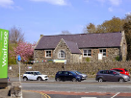
The Telford Centre is a historic former schoolhouse built in 1854.
It is just 300 metres from the Anglesey end of the Menai Bridge.
Its main hall holds around 80 people.

Menai Bridge is the town just across the suspension bridge that
connects Anglesey to Gwynedd. The nearest train station is at
Bangor on the North Wales coast line. The buses X4, 4A, 42, 43 and 53 from Bangor Bus Station into Anglesey all stop at Menai Bridge Bus Station.

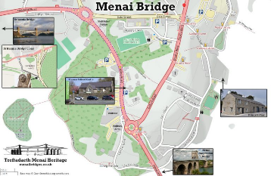
For a printable version of this map download from:
https://menaibridges.co.uk/docs/MHPlacesMap2.pdf

The Anglesey Arms Hotel is opposite the centre and offers accommodation. There are also other accommodation options in Bangor, on the Gwynedd side of the bridge.

To register, or for further information email NFLA or PAWB:
s.morris4@manchester.gov.uk or pawbcymru@gmail.com

SIMULTANEOUS WELSH-ENGLISH TRANSLATION WILL BE AVAILABLE AT
THE MEETING.

